Rising Housing Prices - Full Answer

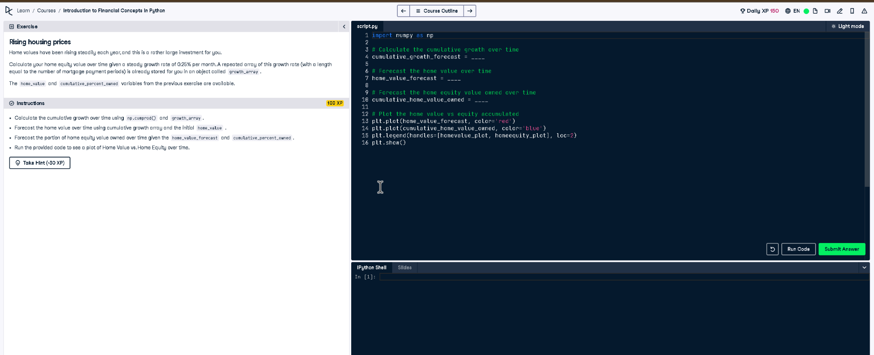

# Full Code Answer:

import numpy as np  
  
# Calculate the cumulative growth over time  
cumulative_growth_forecast = np.cumprod(1 + growth_array)  
  
# Forecast the home value over time  
home_value_forecast = home_value * cumulative_growth_forecast  
  
# Forecast the home equity value owned over time  
cumulative_home_value_owned = home_value_forecast * cumulative_percent_owned  
  
# Plot the home value vs equity accumulated  
plt.plot(home_value_forecast, color='red')  
plt.plot(cumulative_home_value_owned, color='blue')  
plt.legend(handles=[homevalue_plot, homeequity_plot], loc=2)  
plt.show()

# Question:

How do we calculate rising home values and home equity growth over time considering a steady growth rate?

# 20-word Explanation (Question):

Home values increase steadily due to growth rates, requiring cumulative calculations to forecast future value and corresponding home equity.

# Answer:

We use np.cumprod() for cumulative growth, multiply by initial home value, and apply ownership percentage to find equity.

# 20-word Explanation (Answer):

Using cumulative growth with np.cumprod, we forecast future home value and multiply by ownership fraction to get equity trends.